A Virtual Museum for
Cyprian Emeka Uzoh’s Patent
A Birthday Present from His Family, Powered by Rightvarsity Technologies, LLC.
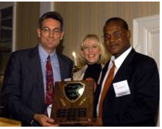
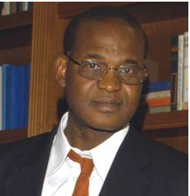
Cyprian Emeka Uzoh was born in Ojoto in Idemili North Local Government Area of Anambra State, Nigeria, His father’s name is Michael Uzoh, and his mother’s name is Gladys Uzoh, He went to Christ the King College (CKC) both for secondary school and high school. He received a Nigerian government scholarship to go to the United States for a bachelor’s degree in Metallurgical Science from University of Wisconsin, Madison. He later went to Rensselaer Polytechnic Institute (RPI), Troy, New York for graduate school. He was scooped as a post doc by IBM where he first showcased his innovative talent to the world through patents.
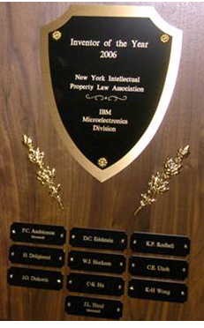
One of his earlier inventions at IBM earned him the Inventor of the Year 2006 because the technology in question came alive in quite a number of industrial and consumer electronics including mobile phones, computers, cameras, camcorders, etc. Since Emeka was working for IBM Microelectronics Division during the invention, the patent technically belongs to IBM. The award came along when he has already left IBM however, the plague was still given to Emeka to keep because he is the key inventor.
Currently, Emeka has over 600 patents worldwide but he has only ----------- (put the number of patents here)patents issued in the United States and a few more that are pending approval in the US Patent and Trademark Office (USPTO). The corporate ownership of Emeka’s inventions span across IBM, ASM, NuTool, Nouvellus, SolorPower, Tessera, Invensas, Ixperi, invensas, and EmekaTech.
Cyprian Emeka Uzoh has three very successful children: Nneka, Amaka, and Nwakaego. He and his wife, Mary (Molly) live in San Jose, California, where they are still contributing to the technological and economic growth of the Silicon Valley and the United.

